K8’s Microservices :

Step 1 :

Create microservice files

And apply files by using kubectl

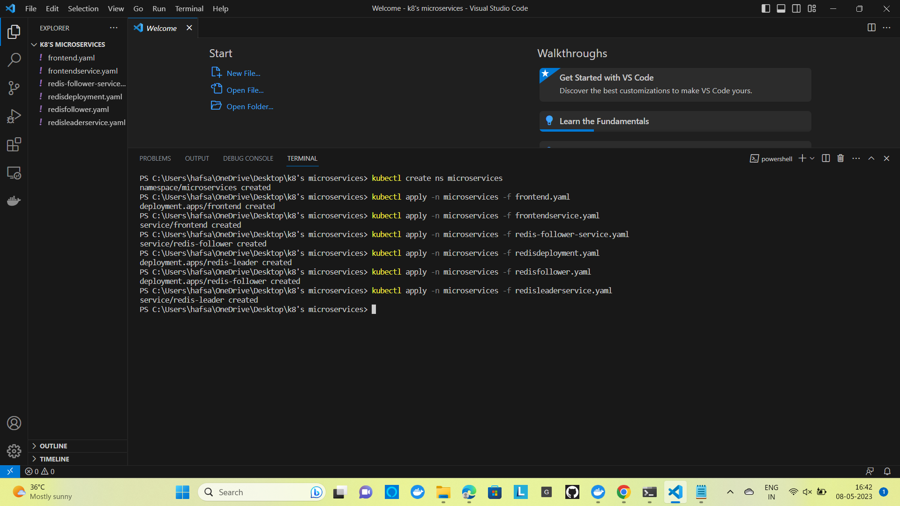

Step 2 :

Kubectl get services -n microservices

Displays the service files in microservice

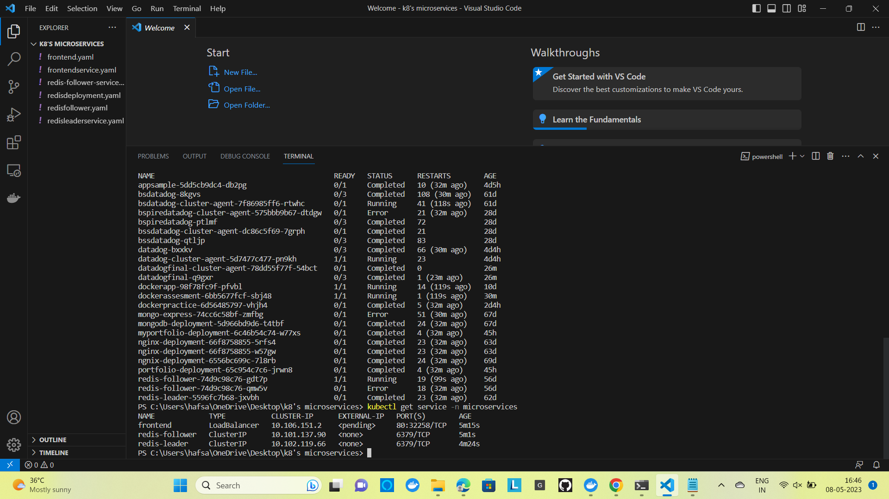

Step 3 : Kubectl get pods -n microservices

Displays the pods in microservices

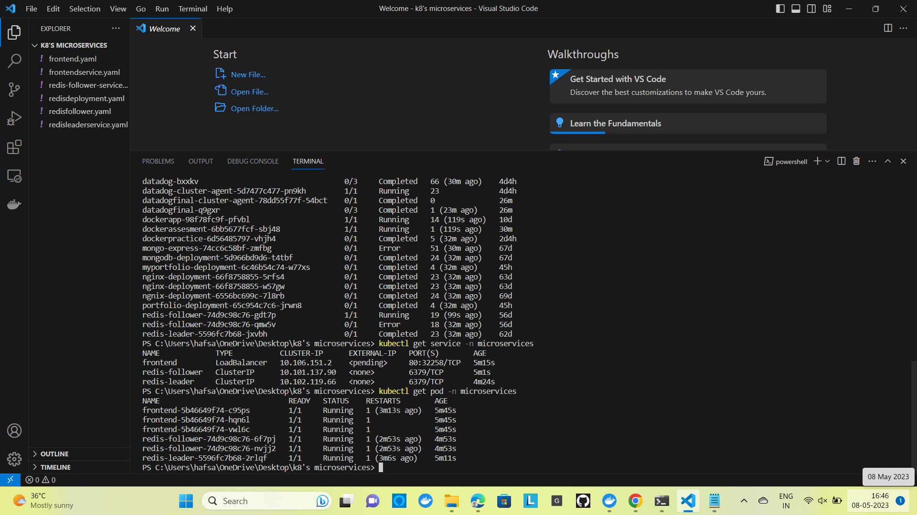

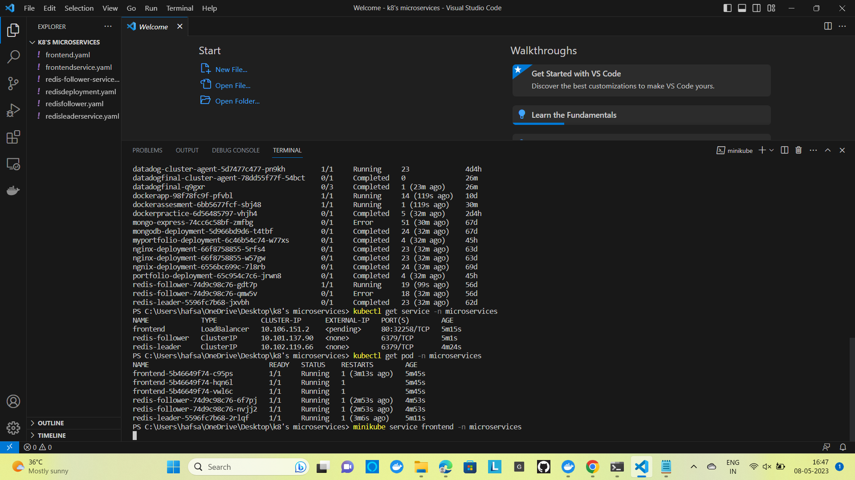

Step 4 :

minikube service frontend -n microservice

Opens in browser

